14-11-2018

GRUPO

**064 – los elementales**

**DOCUMENTO DE DATOS**

**DETALLE DEL MODELO DE DATOS**

En este documento se muestra de manera general el modelo de datos.

1. **DIAGRAMA DE DATOS**

|  |  |
| --- | --- |
| ***Paquete:*** | Vista de diseño |
| ***Detalle:*** | Creado el 14/11/2018 |
| ***Notas*** |  |

**Diagrama de datos**

|  |  |  |
| --- | --- | --- |
| **Creado por:** | Julieth Viviana Cobos Guerrero | |
| **Última modificación:** | 14 de noviembre de 2018 | **Versión:** 1.0 |
|  |  |

Para esta aplicación este es el modelo que se diseñó para el uso del motor de base de datos PostgreSQL.

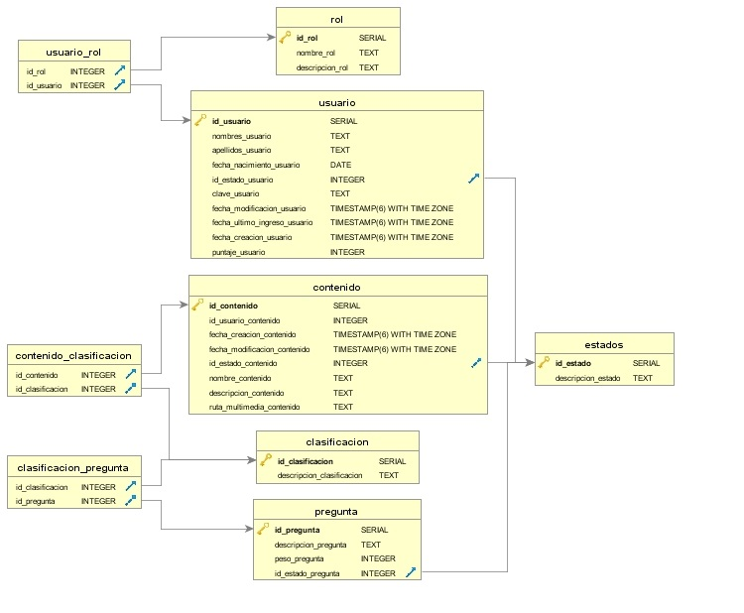

Ilustración 1 Diagrama de datos

1. **MODELO DE BLOQUES**

|  |  |
| --- | --- |
| ***Paquete:*** | Vista de diseño |
| ***Detalle:*** | Creado el 14/11/2018 |
| ***Notas*** |  |

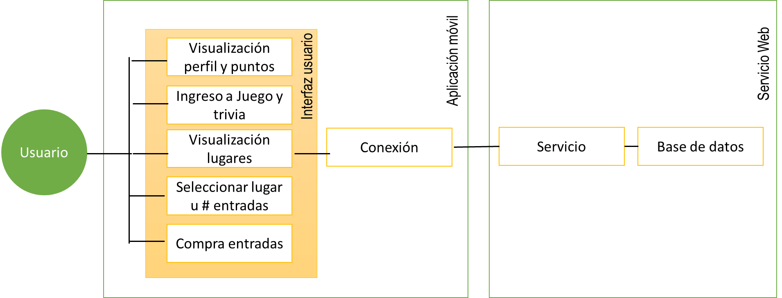

Ilustración 2 Diagrama de bloques

**DICCIONARIO DE DATOS**

A continuación se muestra un listado organizado de los datos del sistema.

|  |  |  |  |
| --- | --- | --- | --- |
| Tabla | Campo | Tipo | Descripción |
| Clasifications | Id | bigint |  |
| Clasifications | clasifications_questions | character |  |
| Clasifications | created_at | timestamp |  |
| Clasifications | updated_at | timestamp |  |
| Clasifications_contents | content_id | bigint |  |
| Clasifications_contents | clasification_id | bigint |  |
| Clasifications_questions | question_id | bigint |  |
| Clasifications_questions | clasification_id | bigint |  |
| Contents | id | bigint |  |
| Contents | nombre_contenido | character |  |
| Contents | descripcion_contenido | character |  |
| Contents | ruta_multimedia_contenido | character |  |
| Contents | created_at | timestamp |  |
| Contents | updated_at | timestamp |  |
| Contents | status_id | bigint |  |
| Contents | user_id | bigint |  |
| Places | id | bigint |  |
| Places | nombre_lugar | character |  |
| Places | direccion_lugar | character |  |
| Places | estado_lugar | character |  |
| Places | puntos_boleta_lugar | character |  |
| Places | created_at | timestamp |  |
| Places | updated_at | timestamp |  |
| Places | descripcion_lugar | character |  |
| Places | img_uri_lugar | character |  |
| Questions | id | bigint |  |
| Questions | descripcion_pregunta | character |  |
| Questions | peso_pregunta | character |  |
| Questions | created_at | timestamp |  |
| Questions | updated_at | timestamp |  |
| Questions | status_id | bigint |  |
| Roles | id | bigint |  |
| Roles | nombre_rol | character |  |
| Roles | descripcion_rol | character |  |
| Roles | created_at | timestamp |  |
| Roles | updated_at | timestamp |  |
| Roles_users | user_id | bigint |  |
| Roles_users | role_id | bigint |  |
| schema_migrations | version | character |  |
| Statuses | id | bigint |  |
| Statuses | descripcion_estado | character |  |
| Statuses | created_at | timestamp |  |
| Statuses | updated_at | timestamp |  |
| Users | id | bigint |  |
| Users |  |  |  |
| Users |  |  |  |
| Users |  |  |  |
| Users |  |  |  |
| Users |  |  |  |
| Users |  |  |  |
| Users |  |  |  |
| Users |  |  |  |
| Users |  |  |  |
| Users |  |  |  |